Swift Zigbee Soil Moisture Sensor
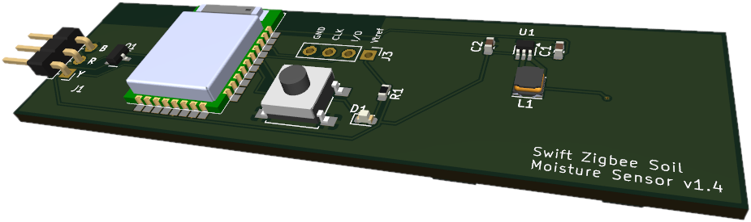
Needed accessories:  - CR2032 battery cell  - Capacitive Soil Moisture Sensor v1.2 | 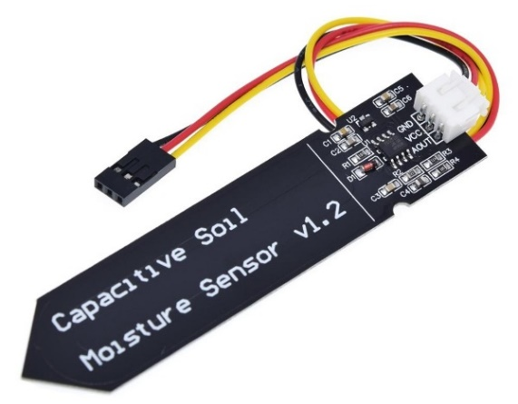

Prepare board
Connect sensor to board using its cable.  The black wire must be connected to the pin B of the Zigbee adapter: | 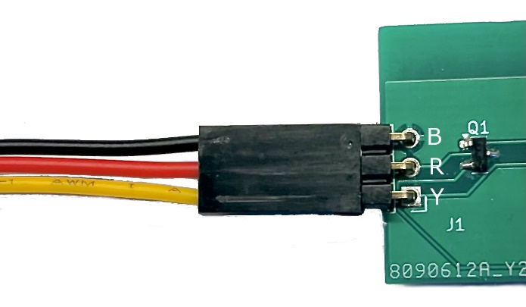

First Pairing
Start your Zigbee Coordinator (Home Assistant for example) and launch pairing operation.
Place Zigbee board near to your coordinator device (approximately a meter away). Insert battery coin promptly into battery socket located at the back of the Zigbee board.
The LED starts to blink on the Zigbee board. Twice per second. Once it has paired with coordinator LED stops blinking. It will lit every 30 minutes when measurement occurs.
Place the whole device where you want to use it.

Factory reset
Remove battery coin. Press SW1 button WHILE inserting the coin back into the socker. LED will blink rapidly. Release the button. Device resets and LED starts to blink again for pairing.

Trouble shooting
In case of values updated as “unknown” or connection loss, just remove and insert battery coin. Verify sensor connection.

